“HOW TO”

MANUAL

… get DVD film on streamer
… convert files with super setup
… choose HD settings
… assign subtitles with DVD Flick

Nevron, d. o. o.
Stegne 21c,
1000 Ljubljana
Slovenia

17.11.2009

Table of content

1. How to get DVD on Streamer Management: 3
2. SUPER SETUP CONVERTER SETTINGS 5
8. HD CONTENT SETTINGS 7
9. ASSIGN SUBTITLES 8

Table of figures

Figure 1: Folder of DVD video in separate peaces 3
Figure 2: CMD prompt window - opened 3
Figure 3: CMD prompt window – path to folder 4
Figure 4: CMD prompt window – process completed 4
Figure 5: Super setup converter screen 5
Figure 6: Marked H264 Profile 7
Figure 7(left): H264 Profile setting screen 7

Table of tables
Table 1: Table of codec settings 6
Table 2: Table of codecs that are supported on streamer 6
Table 3 (right): Table of H264 profile settings 7

How to get DVD on Streamer Management:

- Open DVD with right click on dick name and select Open.
- Open the folder in which are all the video files. See picture bellow for example.

Figure 1: Folder of DVD video in separate peaces

- Movie is in files that are larger than 1GB. In this case are VTS_06_01.VOB, VTS_06_02.VOB, VTS_06_03.VOB, VTS_06_04.VOB. Check the file VTS_06_0.vob, if movie starts with this file, you have to include this too.

- Go to »Start->run-> cmd.exe« or »Start->all programs-> accessories ->command prompt«.
Now you have opened cmd.exe:
Figure 2: CMD prompt window - opened

- Type in »cd« and make space. Then go to My Computer and find the folder in which are files of your movie. Don't open this folder, just select it and move to cmd.exe window. (drag and drop)
You should see something like this: cd »C: ...path to you folder.

Figure 3: CMD prompt window – path to folder
- Click Enter.

- Now you have to type in a command:
copy /b file01.vob + file 02.vob + file 03.vob ...+ file0x.vob Name of new file.vob.
(Bold text is defined; other text is only an example.) In this case you tell which files have to be copied together and in which new file. Name of new file is optional.

Here is our example: copy /b VTS_06_1.VOB + VTS_06_2.VOB + VTS_06_3.VOB + VTS_06_4.VOB + VTS_06_5.VOB DVD_FILM.VOB

- Click Enter.

- You can see that the new file (however you named it) was created in the same folder. When the process is completed, you get information:

Figure 4: CMD prompt window – process completed

- The process is completed. You have new created .vob file in which is the whole movie.
- Now upload this file to FTP server.

SUPER SETUP CONVERTER SETTINGS

Converter- free: Link: http://www.erightsoft.com/S6Kg1.html

- Download super setup converter and install. Link on web: http://www.erightsoft.com/S6Kg1.html (On first page click the Start Downloading SUPER © button at the bottom of the page. On the second page is at the top, bellow the red square - download and use. And on the third page is at the bottom of page - Download SUPER © setup file . After this, the Downloading box appears.)

- When you open it, it looks like this:

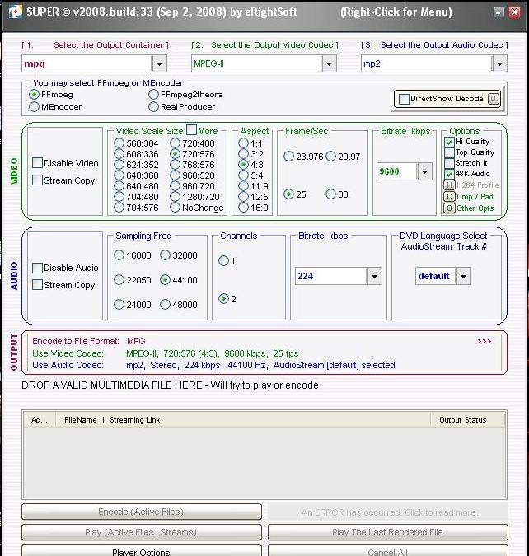
Figure 5: Super setup converter screen

- To choose the right setting this table below may help you. It is necessary to select the settings properly, otherwise video won’t work as you want. Preferred codec are highlighted .

Output container | Output video codec | Output audio codec | VIDEO SETTINGS |  |  |  | AUDIO SETTINGS
 | audio codec | video codec | aspect | frame/sec | min bitrate | max bitrate | sampling freq | channels | bitrate kbps
TS | MPEG2 | AAC LC | 0,6729 | 25 |  |  | 44100 | 2 | 128
TS | h264 | AAC LC | 0,6729 | 25 | 3 | 4 | 44100 | 2 | 128
TS | h264 | AAC LC | 0,6729 | 50 | 6 | 9 | 48000 | 2 | 192
TS | h264 | AC 3 | 0,6729 | 25 | 3 | 4 | 44100 | 2 | 128
TS | MPEG2 | MPEG1/2 | 0,6729 | 25 |  |  | 44100 | 2 | 128
PS | MPEG2 | MPEG2 | 0,6729 | 25 |  |  | 44100 | 2 | 128
PS | MPEG2 | AC 3 | 0,6729 | 25 |  |  | 44100 | 2 | 128
MP4 | h264 | AAC LC | 0,6729 | 25 | 3 | 4 | 44100 | 2 | 192
MP4 | MPEG1 | AAC LC | 0,6729 | 25 |  |  | 44100 | 2 | 192
M2V | MPEG2 | / | 0,6729 | 25 |  |  | / | / | /
MP3 | / | MPEG1/2 | / | / | / | / | 44100 | 2 | 192
MP3 | / | AAC | / | / | / | / | 48000 | 2 | 192
Table 1: Table of codec settings

- Here is a table of formats and codec, which are supported on our Streamer Management.
 | MPEG-2  Video | H.264  Video | MPEG-1 / 2  Audio | AC-3  Audio | AAC (lc)  Audio
Transport Stream - TS | yes | yes | yes | yes | yes
Program Stream- PS | yes | no | yes | yes | no
MP4 File format | Yes | yes | Yes | no | yes
M2V = RAW File format | yes | no | N/A | N/A | N/A
MP3 File format | N/A | N/A | yes | no | No

Table 2: Table of codecs that are supported on streamer

- Select the video for converting:
- Right click on the Gray field and Menu appears. On this menu, click Add Multimedia Files (At the top of the menu). Then select the content you want to convert.

- Select the Output container:
- Select the folder in which the converted content will be saved. Again Right click on the gray field. On this menu, click Output file saving Management and select the Folder.
- Click Encode to start the process.

HD CONTENT SETTINGS

- For HD quality you have to specify a H264 profile. Under Options click button H264 Profile.
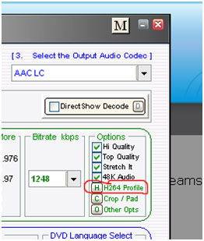
Figure 6: Marked H264 Profile

- After you click the box below appears. Here you set the h264 profile.

HD - mp4, mov | settings
profile | Main (Cabac on)
Levels | 4.2
Ref. Frames | 1

Figure 7(left): H264 Profile setting screen
Table 3 (right): Table of H264 profile settings

- For MP4 format set these settings:
- Output container: MP4
- Output video codec: H.264/AVC
- Output audio codec: AAC LC

- Video: Video scale set to No Change or set the size you want.
Aspect set to 16:9 or 4:3; Frame/sec set to 25. Bitrate set to 9600. (For HD content is recommended above 8000 kbps.)

- Audio: Set Sampling Freq to 44100, Channels to 2 and Bitrate to 128 or 192. (Higher -> better quality).

ASSIGN SUBTITLES

We used DVD Flick program (free program) - Download the latest version
We will show you how to add subtitles. The whole tutorial about DVD Flick is available on link: https://ncteach.wikispaces.com/DVDFlick+software+tutorial
You can also use DVD Flick for converting, because no matter which input format it is, it always makes .VOB output format.
- Click on the DVD Flick icon on the Desktop. The project space will appear.
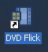
Figure 1
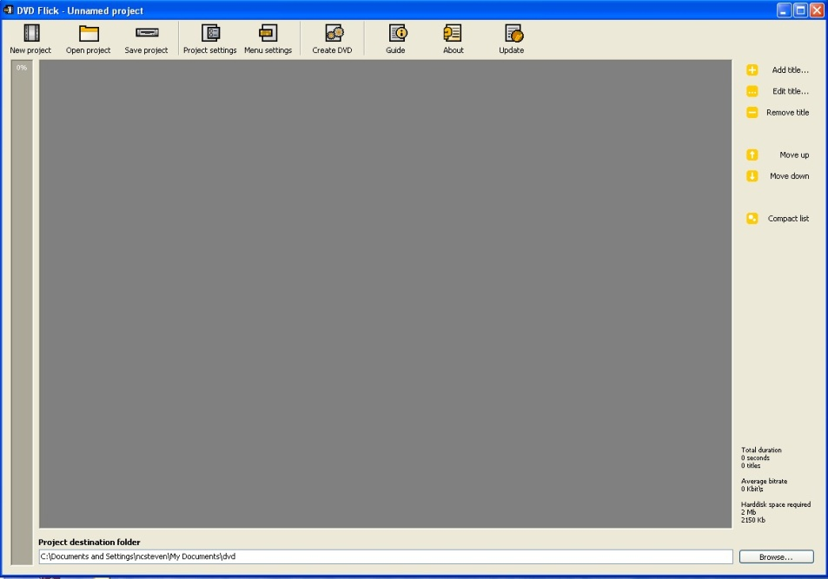
Figure 2

- Select "Add Title" to select a video to be burned (See Figure 3). A dialogue box will appear on the screen (See Figure 4). Highlight the video from the location where it is being stored. Click on the "Open" button. The video will show up in the project space (See Figure 5).
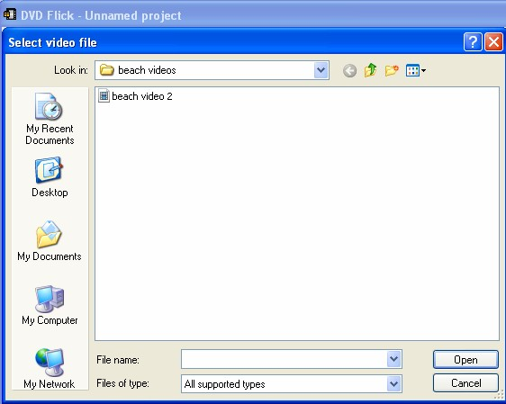
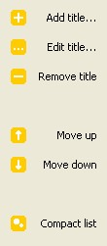

Figure 3 Figure 4
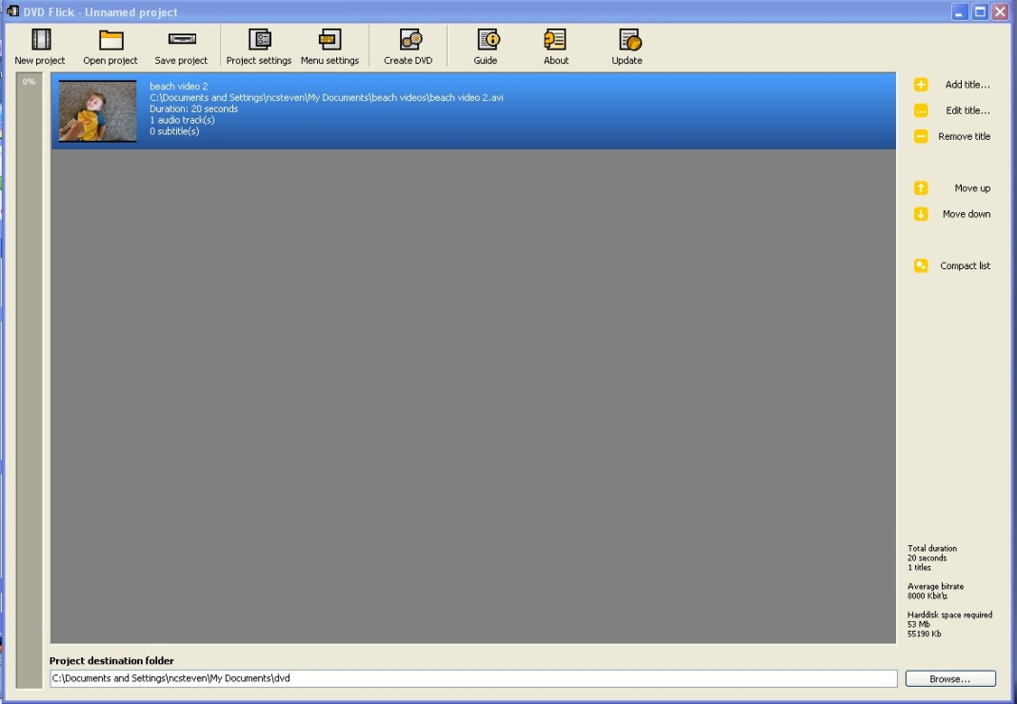
Figure 5

- Click on "Edit title" title button in the right panel (See Figure 6). This will bring up the control panel for the software. The first menu in the left column is labeled "General" (See Figure 7). The title can be changed in the Name textbox. The title that in the textbox will be displayed if a menu is created. If the video is going to be displayed on a standard television, 4:3 will be fine. If the video is going to be shown on a large format screen (ex. LCD or Plasma). To change the size of the screen output, click on the Target Aspect Ratio pull down menu. Select wide screen (16:9) to change the screen size.
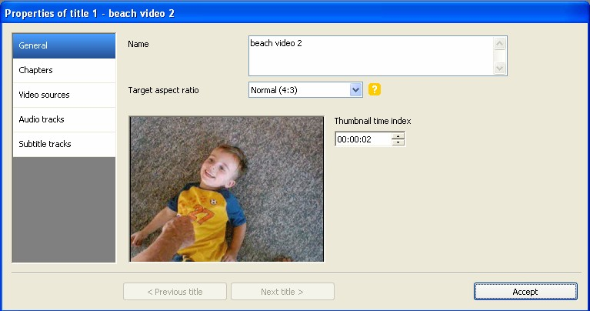
Figure 6 Figure 7

- Click Edit title to open the dialogue box. Here you set all the settings for this video. The first selection in the left column is General, where you can change the name of video and target aspect ratio. Other setting may stay default.

- Other selections may stay default, except last selection in the left column - Subtitle tracks.
Here we set up subtitles for this video. Click Add and choose the subtitles you want to add. Then click Edit button.

- After you click Edit, this window below appears. Set the settings as it’s shown below. I advise you, to leave framerate value default, otherwise subtitles may not keep up with picture.

- Then click Accept twice to leave edit window and click Create DVD button at the top.
Video is made in format .VOB which is appropriate for Streamer. You can also use DVD Flick for converting, because no matter which input format it is, it always makes .VOB output format.
